Optimizing the RF&IF Amplification for Optimal Digitization at the ATA

G. R. Harp  
Rev. 1: 06-Jan-2015

ATA Memo 96

# Introduction

In the process of characterizing the new Antonio feeds, we’re revisiting all the amplifier/attenuator settings from feed to digitizer. The goal is to optimize the RF system to achieve the best possible sensitivity. Optimization requires a series of measurements to characterize the feed and optical link performance, followed by computation of the optimal amplification values for the received signal both at the antenna and in the laboratory. This memo describes a sequence of measurements to determine optimized values for IF and RF amplification (attenuation) for optimal performance at the ATA.

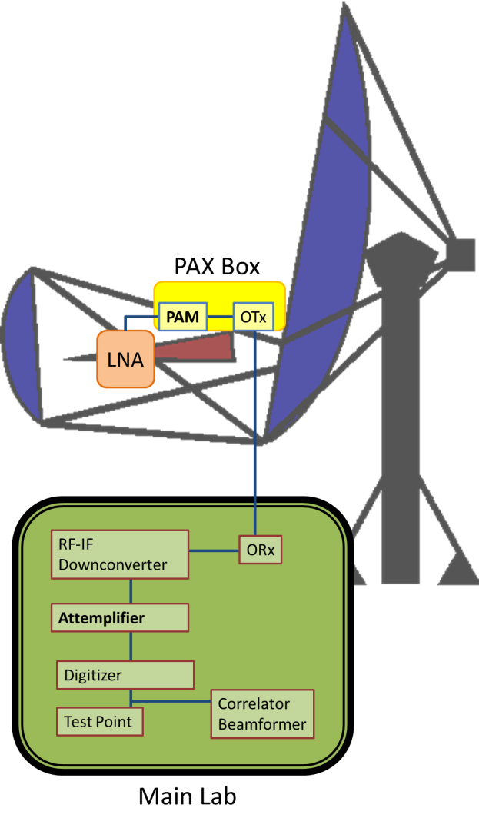

Figure : Schematic of RF and IF elements discussed in this memo.

Figure 1 shows the main elements of the RF (radio frequency) and IF (intermediate frequency) systems for a single antpol. [1] The cryogenically cooled receiver (red triangle) contains a low noise amplifier (LNA), which is followed by the post attenuation module (PAM). Each PAM contains several stages of amplification and attenuation and is controlled through the command-line utilities with “atasetpams” and “atagetpams” commands. The role of the PAM is to adjust the signal level for optimum transmission through the optical link.

The RF signal is fed into an optical link, comprising an optical transmitter (OTx), a length of fiber, and an optical receiver (ORx) to bring the signal back to the main lab. Then the signal passes through the downconverter[2], bringing the 1-10 GHz RF signal down to the IF frequency centered at 630 MHz. The signal is next routed through the attemplifier[3] where the voltage level is optimized for digitization. Following digitization, the “test point” represents command line utilities that are used to interrogate the digitized signal RMS (e.g. “autoattenall.sh”). The digitized signal is also fed to the backend systems, including correlators and beamformers.

When determining the optimal PAM setting for each signal path, we acknowledge that the optimal setting may be weakly frequency dependent. We’ve recently identified significant variations in the noise floor power into the digitizers (aka IBoBs) and improved SNR can be obtained by optimizing the IF amplification in front of the digitizers.

In this memo, we focus on the two controllable elements highlighted with bold text in Figure 1, the PAM and attemplifier. After a preliminary analysis, we outline processes to set these two elements for optimized observing.

# Characterizing the Post-Antenna Signal Properties

The optical links like to be driven with a signal that is large enough to overcome the inherent link noise but not so large that we exceed[4] the link dynamic range.[5] Note that the black-level voltage generated by the receiver itself is closely approximated by a Gaussian probability distribution. Hence we can use the noise power from the feed itself as a fiducial for optimizing the PAM settings.

Figure 2 summarizes test results from all antennas, where the PAM attenuation is varied and the digitized voltage (Test Point) values are measured in the lab. When setting maximum PAM attenuation at the antenna, the noise floor as measured in the lab is dominated by some downstream component. This is seen in Figure 1 where PAM settings from 50-63 do not change the RMS voltage. The most likely candidate for the source of the noise floor is the optical link, and we shall assume this is the case in the discussion to follow.

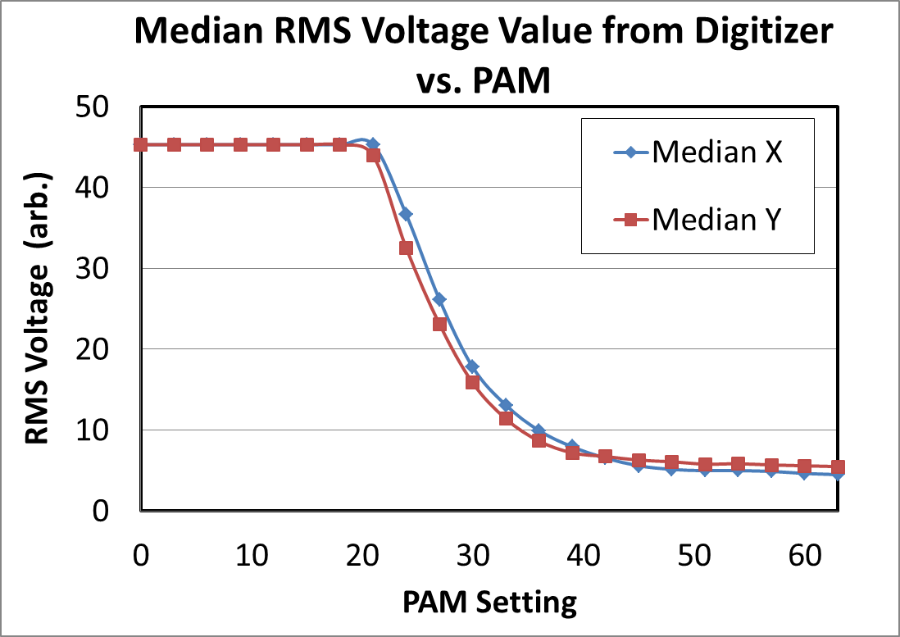

Figure : Measure of the RMS at the digitizer versus PAM setting at the antenna. The curves display the median taken over all antennas. The curves for both X and Y pols are not symmetrical S-curves as expected in a simple amplifier system.

Full PAM attenuation (63 dB) results in a median digitized RMS level of 5 (2.3 bits). An optimally adjusted system would have minimum RMS = 0.5 (0.5 bits), and this is addressed below. By removing all the PAM attenuation we simulate a very strong, broadband noise source at the antenna. Under these conditions the median RMS = 45 (5.5 bits). Converting RMS voltage to log power, the minimum mean square digitizer value is 14 dB and maximum is 33 dB. From this simple measurement we observe that the dynamic range of the (PAM + optical link + downconverter + attemplifier + digitizer) system is 20 dB. This is the value expected based on historical measurements.

The RMS vs. PAM curve does not have the symmetrical S-curve shape expected from a voltage-limited amplifier system. Most of the top half of the S-curve is cut off. Our interpretation is that the input voltage to the downconverter is insufficiently attenuated, causing saturation in the downconverter amplifiers or attemplifiers. Introducing 10 dB of attenuation before the downconverter would bring the entire curve down, and the new median RMS value would be 0.5. Since the top end of the downconverter output would not change, we would see an improved dynamic range and much more of the upper half of the S-curve.

As they are, the current attemplifier adjustment routine (autoattenall.sh) attempts to set the RMS to a value of 13 for ordinary observations. We are losing some sensitivity in all antennas with this setting. The median antenna with minimum RMS = 5 suffers 8% loss in sensitivity. Those antennas where the minimum RMS = 10 suffer 25% loss of sensitivity. Moreover, because the antennas do not all have equal sensitivity, images produced from a non-homogenous array have lower fidelity and more artifacts than a homogenous array.[6] Below we outline a method to choose attemplifier adjustments individually for antennas based on the minimum RMS value. In the future, a better solution may be to introduce a 10 dB pad for each antpol in front of the downconverter, or perhaps in front of the attemplifier depending on which system is hitting the voltage rail. This minimally invasive solution is easily tested on one or two antpols. We suggest that this experiment should be tried at a convenient time to determine whether better dynamic range could be gained with the simple addition of attenuation.

# Setting the Attemplifiers

Whether or not a hardware solution is used, we can improve performance with an individualized attemplifier setting for each antpol. This is especially true for antpols where the baseline link noise is >5. In the course of this work, we may learn that many antennas once considered “poorly performing” can be made to perform better with a simple numerical adjustment.

In Figure 2, the log base-2 minimum voltage is 2.3 bits. The maximum voltage corresponds to 5.5 bits, with a difference of 3.2 bits. While the correlators (4-bits) and beamformers (8-bits) support larger numerical dynamic range, the IF imposes a limit of 3.2 useful bits. We deduce the optimal attemplifier setting for this case (and others) by following the reasoning in (Backer, 2007).

We perform Monte Carlo simulations of sensitivity to antenna noise[7] for digitization. Both the baseline link noise and antenna noise are simulated with zero-mean Gaussian distributions. The simulations use baseline standard deviation (aka. RMS) values of 0.5, 5, 10 and 15. Simulated antenna noise with RMS values 0-43 is added to the link noise. The simulation used 160,000 simulation points for each noise value. The voltage sum at each simulated point is truncated at the value 43 and the RMS of this truncated distribution is computed. Simulations for baseline RMS = 5 are plotted in Figure 3. As expected, small antenna noise levels hardly change the output RMS and large antenna noise saturates toward the value 43.

To find the level of digitizer noise that makes our system most sensitive to antenna noise, we need to find the point of maximum slope in Figure 3. For the various simulated baseline noise values, we compute the first derivative of the digitized RMS with respect to sky RMS and plot these values versus the digitized RMS in Figure 4.

Here we see that the optimal setting for the attemplifier target value depends on the baseline link level. For links with relatively high noise, higher attemplifier target values should be chosen. We also see that the larger the baseline level, the less efficient is the digital response. This is why it is better to fix the baseline level to as low as reasonably possible (RMS~0.5) prior to digitization. And poor choice of attemplifier target value exacerbates this problem.

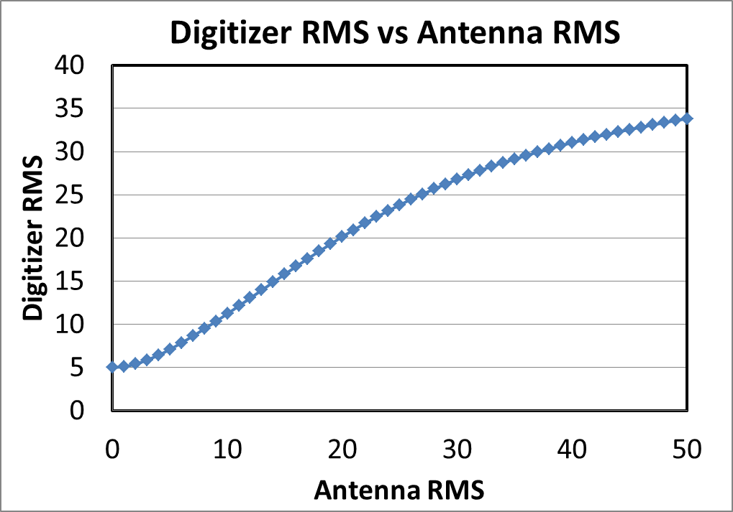

Figure : Results of simulations of measured RMS value at digitizer as a function of the antenna noise RMS for a link noise RMS = 5.

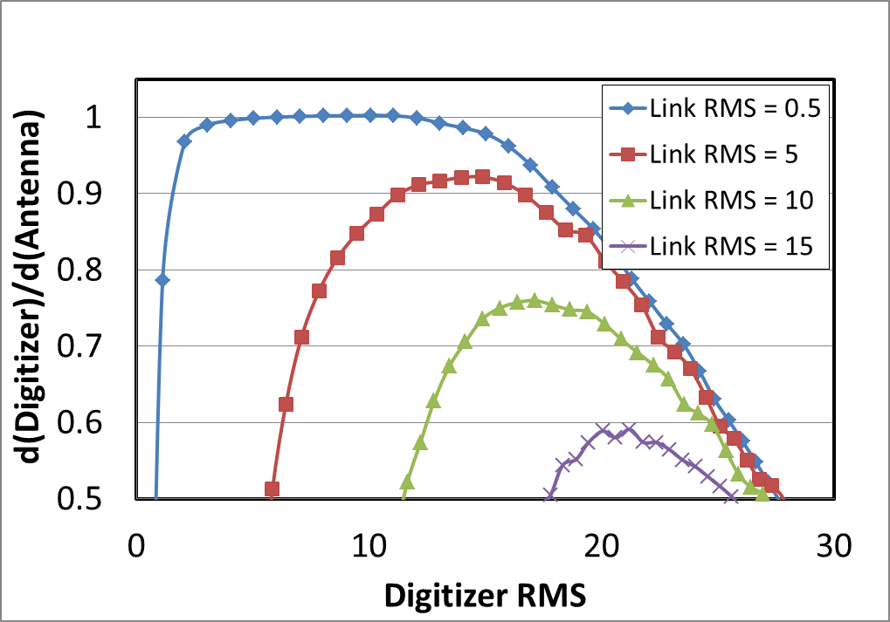

Figure : The numerical first derivative of the simulated digitizer RMS with respect to sky RMS and plotted versus digitizer RMS. In an ideal system, this curve should peak at 1. The peak of each curve represents the point of maximum sensitivity and is dependent upon the

To make attemplifier optimization automatic, we deduce a formula for the best attemplifier setting as a function of baseline link RMS. This analysis is represented in Figure 5. The peak values of the four curves in Figure 4 are plotted versus link noise level and fit with a linear function. Since the data are simulated, one might expect a perfectly smooth plot. The scatter in Figure 5 reveals the limitations of the simulations which presumably would be eliminated with much larger simulated datasets. The quality of data in Figure 5 is sufficient for the purposes of this memo and our needs.

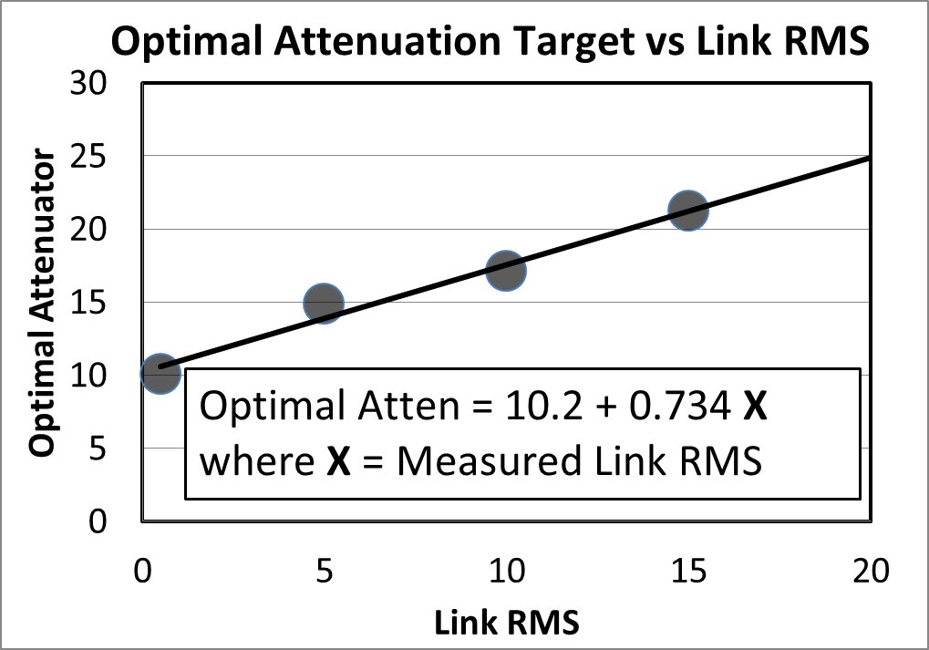

Figure : Plotted values of simulation results for the optimal attemplifier setting versus baseline link noise RMS. Over the range displayed, the formula on the graph provides a good fit.

# Discussion

There are a few details to keep in mind regarding the analysis. One is that we assume the contribution of sky noise to the antenna noise is small. In some cases this approximation breaks down, especially in observations of the sun, GPS, XM radio and other man made sources. To obtain reliable measures of flux in these cases it is necessary to change the PAM settings between observations on and off target. For example, pointing at the sun can raise the antenna noise (aka antenna temperature) by 30 dB, which greatly exceeds the digitizer/IF dynamic range. To accurately observe the sun, one introduces additional attenuation in the PAMs to bring the solar flux “on scale,” so to speak. After the solar measurement is complete, the observed flux of the sun is multiplied by a scale factor before comparison to weaker sources.

Similarly, GPS observations used in pointing observations require extra attenuation. This is not because the receiver is saturated, nor is the optical link necessarily saturated. The weak link in this case is the limited dynamic range of components in the main lab.

Another point regards the “loss of sensitivity” mentioned above for antpols whose optical links have a high noise floor. To be accurate, multiplicative corrections must be made to the signal amplitude from each antenna, a so-called “amplitude gain correction.” To correct antenna the diminished amplitudes, we simply to multiply the affected signals by a factor greater than 1.[sentence syntax is bad] Referencing Figure 4, no correction is needed for link baseline RMS = 0.5, and correction factors of 1.09, 1.31, and 1.72 are required for baseline RMS = 5, 10 and 15, respectively. For links with intermediate RMS values, we use the results of Figure 5 to interpolate between simulated values. Plotted values of simulation results for the optimal attemplifier setting versus baseline link noise RMS. Over the range displayed, the formula on the graph provides a good fit.

For the beamformer, these corrections must be applied on the fly but at present this is not a capability of the beamformer. Fortunately, correlator results may be corrected after the fact. Happily, approximate corrections can be applied to correlator results after the fact. Antenna-based amplitude correction is usually performed during the self-calibration (selfcal) step of correlator reduction. Ideally, these corrections would be applied before selfcal, but approximate corrections can be made using the selfcal program in the MIRIAD package. One observes a quasar or another point source followed by an observation of the target source on the sky. The parameters to selfcal (or mfcal) should include the parameter “options=amp.” This tells selfcal to automatically compute the least-squares best amplitude corrections based on the quasar observation. The gains (amplitude and phase) produced by selfcal are then copied to the target dataset before imaging. Unfortunately, amplitude selfcal is more numerically unstable than regular phase-only selfcal, and care must be taken when using it.

We note that because not all antennas at the ATA are identical, some amplitude self-calibration is required for high-quality imaging.

# Recipe for adjusting the PAMs and Attemplifiers

## Attemplifier Recipe

Here we outline a step by step procedure to optimize the PAMs and attemplifiers with minimal iteration and fast, reliable measurements. While these optimizations can be accomplished through direct observations of quasars followed by sometimes unreliable data reduction, a much faster route uses the ATA command line routine ataautoattenall.sh. Because of potential 2nd order effects mentioned above, it is prudent to cross check the results of the analysis below with quasar observations, just to make sure thing like strong out-of-band signals are not skewing the results.

Before determining the optimal PAM setting we first must optimize the attemplifiers. The autoattenall.sh command takes a numerical parameter as input specifying the target RMS value to be achieved. Until now, this number has always been set to 13, which is a good choice if the link RMS is around 0.5. Instead we begin by calling autoattenall.sh with an impossibly high value, i.e. 50. Assuming we are optimizing for correlator A and the set of antennas to be used are in the fxa group:

1. atasetpams `slist.csh fxa` 63 63
2. autoattenall.sh fx64a:fxa 50
3. mv autoattenall.fx64a.log pam63.log

Command 1 sets the PAMs to maximum attenuation, so the only contribution to digitizer RMS is from the link. Command 2 runs autoattenall.sh. Since all antennas will fail to achieve the target RMS, a warning message for each will be written to the log file. Command 3 renames the log file so that subsequent executions will not overwrite the data.

The output of the log file contains entries similar to the following:

setatten.rb i02.fxa in0 31.5 0 ;: Input level too low. Min atten got 4.8 RMS, wanted 50.0 +/- 0.5 ;

setatten.rb i03.fxa in0 31.5 0 ;: Input level too low. Min atten got 5.0 RMS, wanted 50.0 +/- 0.5 ;

Because the target RMS is not attainable, the attemplifiers measure the RMS with minimum attenuation showing the link noise level. In this example, the link noise RMS is 4.8 and 5 for two antpols. The log data are not labeled with antpol, but with the IBoB number e.g. “i02.fxa.”

We have prepared a java command line program to cross reference the IBoB number to antpol and produce a table of antpol versus link RMS. To invoke this program on the output of command 3:

1. java -cp /hcro/lab/gharp/ata/lib apps.tsys.ProcessAtten pam63.log

Presently, this program is in gharp’s workspace but on the next update from SVN this program will appear in the “apps” branch of the ATA software. The results of command 4 are written to a file called “pamresults.txt.” It contain two long rows comprising a header with antpol values and a line of data displaying the link RMS from each antpol.

At this point, a new program is needed to read in the results of command 4, determine the optimal attemplifier setting, and then set each attemplifier individually to those optimal target values. The optimal attemplifier target value (reference Figure 5) is computed from



where Link RMS is the value taken from the pamresults.txt file.

Note that this entire procedure must be repeated for digitizers running correlator C as well. Since beamformer 1 shares digitizers with correlator C, no further attention is required. An additional repetition is required for the digitizers feeding beams 2 and 3. Similarly, setting up the PAMs is performed on only one set of IBoBs or digitizers at a time.

This completes the optimization of the attemplifier settings.

## PAM Recipe

Next, we use the same autoattenall.sh command to deduce the optimal PAM setting for each antpol. A script that runs autoattenall.sh with 21 different PAM settings is saved to the apps.tsys package under the name “runatten.” This simple script (which could be improved) generates measurements of the digitizer RMS over the full range of the PAMs:

1. sh runatten

The output of runatten is a sequence of log files with names pam00.log, pam03.log, …, pam63.log. To reduce these data files to one large table indexed on antpol, we once again use the java command

1. java -cp /hcro/lab/gharp/ata/lib apps.tsys.ProcessAtten ‘cat logfiles’

Here we have created a simple text file called logfiles with the names of all the pamXX.log files generated by runatten:

Contents of logfile:

pam00.log pam03.log pam06.log pam09.log pam12.log pam15.log pam18.log pam21.log pam24.log pam27.log pam30.log pam33.log pam36.log pam39.log pam42.log pam45.log pam48.log pam51.log pam54.log pam57.log pam60.log pam63.log

The table produced by command 6 is pulled into Excel. From this we create a second table in the spreadsheet that computes the numerical first derivative of the original table:  . To be more explicit, go to the second row of the new table and make an equation that computes the difference between the first and third row of the first table. Copy this equation down the column, stopping at the second to last row.

The results of the second table are examined to find the maximum value for each antpol, which is a measure of the slope of the RMS vs. PAM curve. The PAM setting corresponding to the point of maximum slope is the PAM setting that should be used. At 2900 MHz, we have followed this recipe and determined the values as follows:

Row 1

3X 3Y 4X 4Y 5X 5Y 6X 6Y 10X 10Y 11X 11Y 14X 14Y 15X 15Y 16X 16Y 17X 17Y 19X 19Y 20X 20Y 23X 23Y 24X 24Y 25X 25Y 29X 29Y 30X 30Y 31X 31Y 32X 32Y 33X 33Y 34X 34Y 35X 35Y 36X 36Y 37X 37Y 38X 38Y 39X 39Y 40X 40Y

Row 2

22.5 22.5 19.5 19.5 16.5 19.5 22.5 22.5 25.5 28.5 4.5 19.5 25.5 19.5 4.5 28.5 16.5 25.5 22.5 1.5 31.5 22.5 25.5 25.5 31.5 22.5 28.5 28.5 22.5 25.5 19.5 28.5 10.5 28.5 25.5 25.5 16.5 19.5 25.5 25.5 19.5 7.5 31.5 13.5 25.5 22.5 25.5 31.5 25.5 19.5 22.5 28.5 28.5 34.5

In row 1, the antennas are listed with the MIRIAD numbering scheme. To convert MIRIAD numbers (e.g. 3) to the usual antenna names (antenna 1c) use a command like:

1. ataant2miriad --opp 3

The results of this command look like this: “ant3 1c.”

A short script can automate the conversion from MIRIAD numbers to antenna names. Ultimately, there needs to be a program, possibly in java, that incorporates the functions of runatten and iterates over frequency, then converts MIRIAD numbers to antenna names.

We anticipate that the optimal PAM setting might be frequency dependent. At the top of the runatten script, there is an atasetskyfreq command which sets the frequency before running the main script. The frequency should be varied with values 900, 1900, 2900, 3900, 4900, 5900, 6900, 7900, 8900, 9900[8] and the optimal PAM determined at each frequency.

Once the optimal PAM settings have been determined, it is easy to add these values into the online PAM database. Use a command similar to:

1. atasetpams 1c “2900” 22.5 22.5

Command 8 not only sets the antenna to the indicated values, but installs those values in the database with the name “2900.” To recall those values from the database and set the antenna PAMs to that value, use:

1. atasetpams 1c 2900

The name used above can be any string. The string “default” has a special property. If one issues an atasetpams command without a name modifier:

1. atasetpams 1c

then the database values with the label “default” are used.

Again, this process can be automated with a simple program, installing the optimal PAM values for all antennas in one go. Once for each measured frequency.

After all the optimal PAMs are determined, we should change our software so that it chooses the correct PAM setting for each antenna based on its frequency, calling from the database the PAM setting closest to the observing frequency.

1. Antpol is a contraction of the words antenna-polarization. Each antenna measures a horizontal and vertical polarization labelled X and Y respectively. For example, one antpol is named 3cX, where 3c refers to the antenna and X designates the X-polarization.
2. The device that converts a selected sky frequency (1-10 GHz) to an “intermediate” frequency suitable for digitization. At the ATA, the IF = 630 MHz.
3. A custom attenuation-amplification system at the ATA which adjusts the IF voltage. Its nickname is attemplifier.
4. In principle this is impossible since we measure signals that closely approximate Gaussian noise and occasional voltage spikes will exceed the link dynamic range. Instead the processes described here shall limit such voltage spikes to an acceptable level.
5. Because the link bandwidth is much greater than the digitized bandwidth, might overdrive the optical link at frequencies not received at the digitizer. For now, our analysis will ignore 2nd order effects. This second order effect is potentially a problem because of the out of band emission from mixing products in the RFCB – it looks like that stuff is just beyond the edge of the filter so doesn’t get through – at least at some level.
6. Using amplitude self-calibration can mitigate the non-homogeneity of the array, but amplitude self-cal is numerically unstable and less reliable than having an homogenous array to begin with.
7. While the antenna noise is dominated by receiver noise, there is a small component from the sky. Thus sensitivity to antenna noise is equivalent to sensitivity to sources on the sky.
8. We avoid round numbers such as 2000 MHz because there man made interference is seen more often at those frequencies.